Hyperparameter tuning in python
H YP E RPA RA M E TE R TUN IN G IN P YTH ON
312621243014 – HARISH M
Alex Scriven Data Scientist

Introduction

New, complex algorithms with many hyperparameters
Tuning can take a lot of time
Develops deeper understanding beyond the default settings You may be surprised what you nd under the hood!

The dataset

The dataset relates to credit card defaults.
It contains variables related to the nancial history of some consumers in Taiwan. It has 30,000 users and 24 attributes.
Our modeling target is whether they defaulted on their loan
It has already been preprocessed and at times we will take smaller samples to demonstrate a concept
Extra information about the dataset can be found here:
https://archive.ics.uci.edu/ml/datasets/default+of+credit+card+clients

Parameters Overview

What is a parameter?
Components of the model learned during the modeling process
You do not set these manually (you can't in fact!)
The algorithm will discover these for you
A simple logistic regression model:
log_reg_clf = LogisticRegression()

log_reg_clf.fit(X_train, y_train)

print(log_reg_clf.coef_)

array([[
-2.88651273e-06
,
-8.23168511e-03
,
7.50857018e-04
,

3.94375060e-04
,
3.79423562e-04
,
4.34612046e-04
,

4.37561467e-04
,
4.12107102e-04
,
-6.41089138e-06
,

-4.39364494e-06
, cont... ]])

Tidy up the coef cients:
# Get the original variable names original_variables = list(X_train.columns)
# Zip together the names and coefficients
zipped_together = list(zip(original_variables, log_reg_clf.coef_[0]))
coefs = [list(x) for x in zipped_together]
# Put into a DataFrame with column labels
coefs = pd.DataFrame(coefs, columns=["Variable", "Coefficient"])

Now sort and print the top three coef cients
coefs.sort_values(by=[
"Coefficient"
]
, axis
=
0
, inplace=
True
, ascending=
False
)
print(coefs.head(
3
))

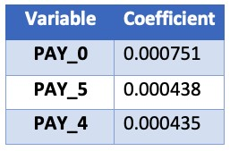

Where to nd Parameters

To nd parameters we need:
- To know a bit about the algorithm
- Consult the Scikit Learn documentation
Parameters will be found under the 'Attributes' section, not the 'parameters' section!

Parameters in Random Forest
What about tree based algorithms?
Random forest has no coef cients, but node decisions (what feature and what value to split on).
# A simple random forest estimator

rf_clf = RandomForestClassifier(max_depth=
2
)

rf_clf.fit(X_train, y_train)

# Pull out one tree from the forest

chosen_tree = rf_clf.estimators_[
7
]

For simplicity we will show the nal product (an image) of the decision tree. Feel free to explore the package used for this (graphviz & pydotplus) yourself.
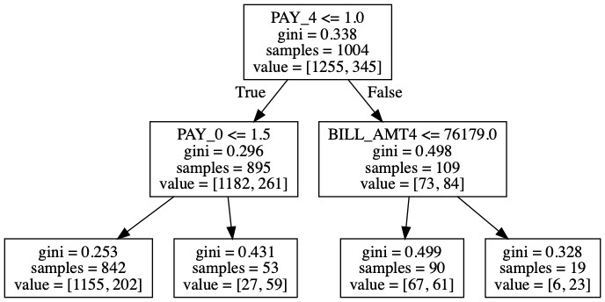

Extracting Node Decisions
We can pull out details of the left, second-from-top node:
# Get the column it split on split_column = chosen_tree.tree_.feature[1] split_column_name = X_train.columns[split_column]
# Get the level it split on split_value = chosen_tree.tree_.threshold[1] print("This node split on feature {}, at a value of {}" .format(split_column_name, split_value))
"This node split on feature PAY_0, at a value of 1.5"

H YP E RPA RA M E TE R TUN IN G IN P YTH ON
Hyperparameters Overview
H YP E RPA RA M E TE R TUN IN G IN P YTH ON

Alex Scriven Data Scientist

What is a hyperparameter
Hyperparameters:
Something you set before the modelling process (like knobs on an old radio) You also 'tune' your hyperparameters!
The algorithm does not learn these
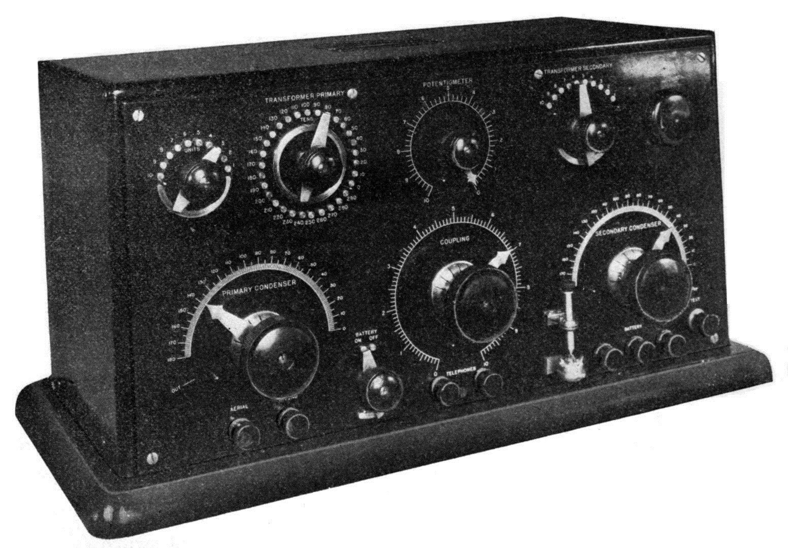

Hyperparameters in Random Forest
Create a simple random forest estimator and print it out:
rf_clf = RandomForestClassifier()
print(rf_clf)
RandomForestClassifier(n_estimators='warn', criterion='gini', max_depth=None, max_features='auto', max_leaf_nodes=None, min_impurity_decrease=0.0, min_impurity_split=None, min_samples_leaf=1, min_samples_split=2, min_weight_fraction_leaf=0.0, n_jobs=None,
oob_score=False, random_state=None, verbose=0,bootstrap=True, class_weight=None, warm_start=False)
More info: http://scikit-learn.org

A single hyperparameter
Take the n_estimators parameter.
Data Type & Default Value: n_estimators : integer, optional (default=10)
De nition:
The number of trees in the forest.

Setting hyperparameters
Set some hyperparameters at estimator creation:
rf_clf = RandomForestClassifier(n_estimators=100, criterion='entropy')
print(rf_clf)
RandomForestClassifier(n_estimators=100, criterion='entropy', max_depth=None, max_features='auto', max_leaf_nodes=None, min_impurity_decrease=0.0, min_impurity_split=None, min_samples_leaf=1, min_samples_split=2, min_weight_fraction_leaf=0.0, n_jobs=None,
oob_score=False, random_state=None, verbose=0,bootstrap=True, class_weight=None, warm_start=False)

Hyperparameters in Logistic Regression
Find the hyperparameters of a Logistic Regression:
log_reg_clf = LogisticRegression()
print(log_reg_clf)
LogisticRegression(C=1.0, class_weight=None, dual=False, fit_intercept=True, intercept_scaling=1, max_iter=100, multi_class='warn', n_jobs=None, penalty='l2', random_state=None, solver='warn', tol=0.0001, verbose=0, warm_start=False) There are less hyperparameters to tune with this algorithm!

Hyperparameter Importance

Some hyperparameters are more important than others.
Some will not help model performance:
For the random forest classi er: n_jobs random_state verbose
Not all hyperparameters make sense to 'train'

Random Forest: Important Hyperparameters

Some important hyperparameters:
n_estimators (high value) max_features (try different values) max_depth & min_sample_leaf (important for over tting) (maybe) criterion
Remember: this is only a guide
How to nd hyperparameters that matter?

Some resources for learning this:
Academic papers
Blogs and tutorials from trusted sources (Like DataCamp!)
The Scikit Learn module documentation
Experience

H YP E RPA RA M E TE R TUN IN G IN P YTH ON
Hyperparameter Values
H YP E RPA RA M E TE R TUN IN G IN P YTH ON

Alex Scriven Data Scientist

Hyperparameter Values

Some hyperparameters are more important than others to begin tuning.
But which values to try for hyperparameters?
Speci c to each algorithm & hyperparameter
Some best practice guidelines & tips do exist Let's look at some top tips!

Con icting Hyperparameter Choices
Be aware of con icting hyperparameter choices.
LogisticRegression() con icting parameter options of solver & penalty that con ict.
The ‘newton-cg’, ‘sag’ and ‘lbfgs’ solvers support only l2 penalties.
Some aren't explicit but will just 'ignore' (from ElasticNet with the normalize hyperparameter):
This parameter is ignored when fit_intercept is set to False
Make sure to consult the Scikit Learn documentation!

Silly Hyperparameter Values

Be aware of setting 'silly' values for different algorithms:
Random forest with low number of trees
Would you consider it a 'forest' with only 2 trees?
1 Neighbor in KNN algorithm
Averaging the 'votes' of one person doesn't sound very robust!
Increasing a hyperparameter by a very small amount
Spending time documenting sensible values for hyperparameters is a valuable activity.

Automating Hyperparameter Choice

In the previous exercise, we built models as:
knn_5 = KNeighborsClassifier(n_neighbors=5) knn_10 = KNeighborsClassifier(n_neighbors=10) knn_20 = KNeighborsClassifier(n_neighbors=20)
This is quite inef cient. Can we do better?

Automating Hyperparameter Tuning
Try a for loop to iterate through options:
neighbors_list = [3,5,10,20,50,75] for test_number in neighbors_list:
model = KNeighborsClassifier(n_neighbors=test_number) predictions = model.fit(X_train, y_train).predict(X_test) accuracy = accuracy_score(y_test, predictions) accuracy_list.append(accuracy)

Automating Hyperparameter Tuning
We can store the results in a DataFrame to view:
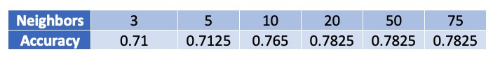
results_df = pd.DataFrame({
'neighbors'
:
neighbors_list,
'accuracy'
:
accuracy_list
})
print(results_df)

Let's create a learning curve graph
We'll test many more values this time
neighbors_list = list(range(5,500, 5)) accuracy_list = [] for test_number in neighbors_list:
model = KNeighborsClassifier(n_neighbors=test_number) predictions = model.fit(X_train, y_train).predict(X_test) accuracy = accuracy_score(y_test, predictions) accuracy_list.append(accuracy) results_df = pd.DataFrame({'neighbors':neighbors_list, 'accuracy':accuracy_list})
We can plot the larger DataFrame:
plt.plot(results_df[
'neighbors'
]
,

results_df[
'accuracy'
])

# Add the labels and title

plt.gca().set(xlabel=
'n_neighbors'
, ylabel=
'Accuracy'
,

title=
'Accuracy for different n_neighbors'
)

plt.show()

Our graph:
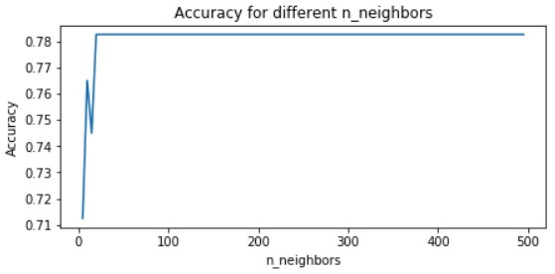

A handy trick for generating values
Python's range function does not work for decimal steps.
A handy trick uses NumPy's np.linspace(start, end, num)
Create a number of values ( num ) evenly spread within an interval ( start , end ) that you specifyH YP E RPA RA M E TE R TUN IN G IN P YTH ON

